5 improvements that aren’t BobVila Jan ‘13

http://www.bobvila.com/articles/27473-5-smart-home-improvements-think-again/pages/1

- More Home Improvement > Buying & Selling Homes > 5 Smart Home Improvements? Think Again!
5 Smart Home Improvements? Think Again!
Before you find yourself saying, "What was I thinking?" see what five home upgrades topped last year's list of loss leaders.
By JOANNE CLEAVER

Photo: Landmark Custom Homes
Built-in aquariums: the amenity that quickly becomes an eyesore.
Of all the misfired home improvements that Daniel Fries has observed in his 30 years as a home appraiser, aquariums top his list of 2012 loss leaders—home improvements that offered little to no return on investment.
“It’s not a prudent investment,” deadpans Fries, who is based in Atlanta, GA. The tank's glass fogs, while grimy filters emit an odor of rotting seaweed. Even worse—yes, it gets worse—some owners repurpose fish aquariums as reptile dwellings. And few things send a potential home buyer fleeing faster than the sight of a bull snake in the dining room.
Aquariums top our list of "improvements" with poor return on investment, but every projects on that list has at least one thing in common: a profound mismatch between a homeowner’s intent and a neighborhood's standards.
Local culture, preferences, and market conditions dictate return on improvements. Sink your money into amenities that don’t reflect the norm for your immediate area and you won’t even gain a 5% premium over neighboring homes, regardless of what you spent, says Kevin Cross, owner of the Anchorage, AK-based real estate agency Cross & Associates.
Case in point: Granite countertops actually undermine market value in Alaska. Extreme temperature changes force constant settling and resettling of home foundations, which results in warping and cracking of solid stone surfaces. Laminate gives just enough to make it the counter material of choice.
"Understand that anyone looking for a house is going to stand in front of yours with their cell phone looking at all the estimated values of the houses all around yours," he continues. "When a buyer looks at a house, they’re not looking for reasons to buy a house. They’re looking for reasons to not buy yours. Your job is to remove as many of those reasons 'not to buy'. If it’s priced right, clean, staged and looks inviting, an older house will sell faster than a new house even with superior amenities."
Buyers pick up on price discrepancies immediately and aren’t willing to pay for misguided improvements... like the rest of the items on our list of top don’ts.
Loss leader #2: Built-in electronics Bragging rights last only a few months when it comes to the latest televisions and sound systems. Once the next gizmo lands on the market, today’s shiny toy quickly tarnishes. The value added by splurging for top-of-the-line freestanding electronics may be debatable, but at least you can easily take the gear with you. Built-ins often dominate the entire room and their reverberations can erode the usability of adjoining rooms, too.
The owner of a $3 million house bragged to Fries that his built-in sound system cost $650,000. That was overkill even for a mansion. "He could have spent $50,000 on the media room and gotten just as much value from it," says Fries. "You have to consider electronics as personal property, even if they are built in."
Loss leader #3: Eliminating a third or fourth bedroom. Sure, a walk-in closet and expanded master bath would be a selling point—but only if that space isn’t hijacked from a third or fourth bedroom. If the neighborhood norm is three bedrooms, a two-bedroom house is at a severe disadvantage. The number of bedrooms should be in balance with the common living space. A house with too many or too few bedrooms has a lopsided layout that won’t be useful to many buyers. Still want that master closet? You might be able to justify it if you apply the second cardinal rule of return (keep reading).
Loss leader #4: Overimproving the basement. Below-grade improvements never pay back as much as space renovated or added above grade. Carefully compare the cost of renovating the attic, adding a dormer or even raising the roof, to a high-end basement remodel. This is especially true for mid-priced houses. High-end houses may well be able to retain the value of a finished basement, but only if all the above-grade space is livable.
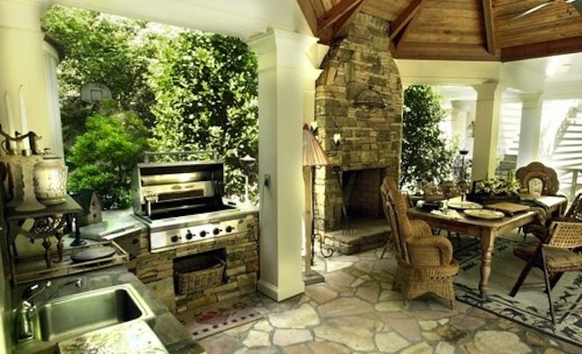
Loss leader #5: Expansive outdoor living space out of synch with the climate. Outdoor kitchens with manly grills and wood counters can be used ten months a year in the South, so those projects retain value, says Fries. Not so much in the North, where a fireplace is a cozier investment. Cross reports that water features don’t sell Alaskan houses, considering that they are under four feet of snow for half the year. Especially if you are relocating, settle in to the local lifestyle before creating a sunroom, screened porch, elaborate deck or outdoor kitchen.
Each of these horrors is grounded in the grand misconception of home improvement: if you build it, they will pay. Fries explains that appraisers’ guidelines will force a challenge from the lender if improvements boost the market value of the house more than 10% from its value without the improvement. As you scope out the budget for your project, keep the total tab to no more than 10% of the current value of your house. Spend more only if you count the payback in terms of personal enjoyment.
Use as a reference Remodeling magazine’s annual Cost vs. Value Report. The regional breakouts chart the cost of remodeling, the return, and the difference. The averages are useful for benchmarking estimates and can help you set expectations from the start.
It can be a balancing act to polish to the point of perfect return, especially if you expect to sell the house soon. Consider putting in one moderately priced focal point improvement that can make the room memorable. For example, one—just one—built-in specialty appliance in the kitchen can be a selling point. That appliance might be a warming drawer, or a wine cooler, or a five-burner stove with a griddle instead of the standard four-burner stove. Even then, calculate your payback in terms of a shorter selling time, not in terms of dollar return.
There is an antidote to misfired improvements. Appraisers call it the 'cost to cure,' and it’s the second cardinal rule of return. How much will it cost to rip out the offending amenity and make that part of the house look, well, normal?
The cost to cure a derelict aquarium is only about $1,000. The cost to revert a walk-in closet to a bedroom could be as little as $500. But the cost to rip out an algae-clogged, crumbling swimming pool could run ten times that. When in doubt, get two estimates: one to put in the improvement, the other to take it out.
If you must have it, budget time and money for the 'cure', and make sure you squeeze every moment of happiness from that feature in the meanwhile.
MORE IN HOME IMPROVEMENT
3 Top Ways to Capture Value in 2013
Bob Vila Radio: Pocket Neighborhoods
Remodeling Heats Up
A Little Income Adds a Lot of Value
House Hunting in Plymouth, MA
SEE ALSO
10 "Neat" Garage Storage Solutions
11 Sneaky Storage Ideas
Get Organized: 20 Clever Ideas for Repurposed Storage
15 Ways to Make a Small Bathroom Big
10 Things to Do with... Cross-Cut Trees

INSPIRATION GALLERY
- 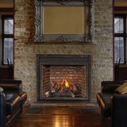
- Gas Fireplaces: A Showcase of Design and Innovation
- 10 Dramatic Garage Transformations
- 11 Ways to Use Salvaged Wood in Your Home
- 12 "Expert Picks" for Fail-Safe Colors
- 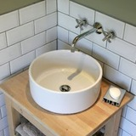
- 10 Ingenious IKEA Hacks
- 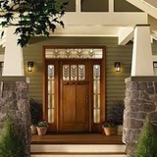
- 10 Eye-Catching Options for Your Front Door
- 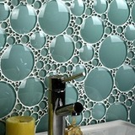
- 11 Backsplashes for a Unique Kitchen
- 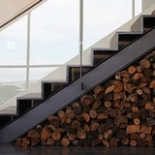
- 12 "Different" Ways to Store Firewood
- 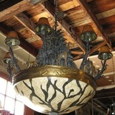
- 10 Reasons to Love Architectural Salvage
- 30 Storage Ideas for Under the Stairs
- 11 Ways to Winterize Your Home on a Budget
- 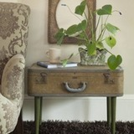
- 20 Clever Ideas for Repurposed Storage
- 10 Space Heaters We Love
- 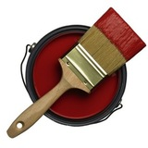
- Paint Guide: 10 Essentials for Successful House Painting
- 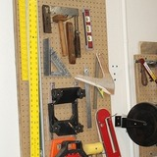
- Pegboard Storage: A Classic for All-Time
- 10 Design Inspirations for Mudrooms and Entryways
- 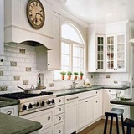
- Painted Cabinets: 10 Reasons to Transform Yours Now
- 12 "Different" Ways to Store Firewood
- Bob Vila's Guide to Historic House Styles
- 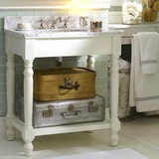
- 15 Ways to Make a Small Bathroom Big
- 1 2 3 4 5 6 7
5 Easy-Install Smart Light Switches | 12 Creative Ways to Use Old Dishes | 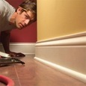  Top 10 Carpentry Tips & Tricks | Kim Kardashian & Kanye West Buy $11M Fixer-Upper

Exploring 6 Grand Abandoned Mansions | How to Paint Faster! | 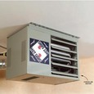  How to Heat a Garage | 7 Ways to Warm Up a Cold Room
MOST POPULAR
- Radiant Floor Heating 101
- Dream House for IKEA Lovers
- 5 Thrifty DIY Organization Ideas
MOST SHARED
MOST VIEWED VIDEO

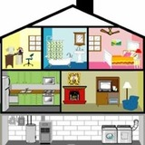
Bob Vila's 5 "Must Do" Projects for January
Introducing 2013's Color of the Year!
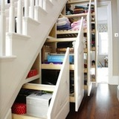
11 Sneaky Hidden Storage Ideas
10 Alternative Wreaths to Make You Forget About Evergreens
30 Amazing Minimalist Japanese Houses
Gas Fireplaces: 10 Innovative Designs
FOLLOW US

- Browse this site Kitchen Bathroom Painting Tools & Workshop Lawn & Garden More Home Improvement Bob's Blogs TV
Bob Vila.com
- About Bob Advertise with Us Press Info Contact Us Privacy Policy Terms of Use
Copyright © 2013 Bobvila. All rights reserved
webapp1

